**Environmental Management**

**Predesign**

**for Pollution**

**Prevention and Control**

|  |  |
| --- | --- |
| **GAEL D. ULRICH**  **PALLIGARNAI T. VANIUDEVAN UNIV. OF NEW HAFAP5NIRE** | A plant's **intrinsic cleanliness is  determined during the predesign stage.** This article **provides guidance for making  critical decisions during preliminary design.** |

**D**

uring the past few decades, pollution prevention and control has assumed a prominent role in the chemical engineering profession. Its study has

become part of chemical engineering curricula throughout the world, *and a* new section on waste treatment has been added to "Perry's Chemical Engineers' Handbook."

The major responsibility for an operating plant's clean­liness falls on its operators. final designers, contractors and maintenance personnel, but its inherent cleanliness is defined before construction. Preliminary designers don't have the time or budget to fully scope a waste system and secure permits, but they can radically improve process cleanliness by devising ways to recycle **or** reuse streams and minimize or eliminate end-of-pipe remedies.

The three types of **emissions are** fugitive. native and engineered emissions. Fugitive missions (I) are the diffi­cult-to-find, -control or -capture leaks from pipe joints. storage tank vents, and static or rotating seals. They include leaking gases, dripping lubricants and evaporating solvents. Final designers and contractors are charged with preventing their escape. Operators and maintenance people are responsible for finding and eliminating them. Preliminary designers can do little to prevent fugitive emissions other than to specify materials and equipment that will contain process streams responsibly,

Native emissions are discharges from equipment such as furnaces, cooling towers and other devices that burn fuels or generate a utility stream. Process designers must usually accept whatever emissions are defined by avail­able *fuels* and prevailing technology.

A predesigner's major concern is engineered emissions — that is, those from process vessels, reactors and separa­tors, where engineering can influence the nature and quan­tity of effluent streams. The aim of this article is to help budding process analysts reduce or eliminate engineered emissions in pmiects that they influence.

**Principles of pollution prevention and waste minimization *(3-61***

Noxious byproducts that leave a **process 'nodule** must be treated by "end-of-pipe" techniques before they can be discharged to the environment. This is costly, both eco­nomically and politically. Ideally, the goal of pollution pre­vention. or P2, is not simply to reduce noxious emissions. but to avoid creating them in the first place, In this regard, safety expert Trevor Kletz's famous adage, "What you don't have, can't leak" can he aptly rephrased and applied to environmental protection: "What you don't emit, can't pollute." This premise leads to the following hierarchy of pollution-prevention/waste-minimization rules OR

*I. Source reduction.* Faced with a serious emissions problem, consider alternative processes or different feed­stocks that do not create noxious byproducts. If complete elimination of a pollutant is not feasible, modify the process to reduce its quantity.

Many chemical processes employ choncle-containing feedstocks, for instance. where non-halogenated substances might be used instead. The latter can often be converted to natural substances like water and carlxin dioxide, whereas chlorides are not easily transformed to a non-polluting form.

**CM,** Jung 207 **voromaidacogicip ■11**

Reproduced with permission of the copyright owner. Further reproduction prohibited without permission.

**Environmental Management**

**Table 1. Predesign for pollution prevention involves four basic steps.**

**Step**

1. **Identify**
2. **Eradicate**

**(PP rules 1 and 2;**

**process substitution,**

**source reduction, reuse, recyclel**

1. **Minimize**

**(PP rule 3, treatl**

1. **Isolate (PP rule 4! ultimate clitiPosali**

**Tools**

1. **Weil-executed process now diagram**
2. **List of pollution-related properties**
3. **Stream hazard chart (on flowsheet)**
4. **Permissible emissions chart**
5. **Consider alternative prOCessS**
6. **Explore conversion efficiency improvements**
7. **Check internal recycle possibilities**
8. **Consider marketable disposal of wastes 1. Tables 3 and 4: Figures I. 2 and 3**

**1. Table 4**

**Experimental and Analytical Resources**

**Equilibrium calculations**

**Mass balances**

**BOO and other analytical testing Reactor design calculations**

Equilibrium **calculations**

**Mass balances**

**BOO and other analytical testing Reactor design calculations**

**Sound chemical engineering analytical and computational skills**

**Sound chemical engineering judgment, responsible legal advice, and common sense**

**Table 2. Relevant pollution-related properties of ecrylonitrIle.**

**Property** Data **Comments**

**Formula Cleat colorless liquid at room**

**Molecular Weight 53 temperature with a faintly**

**Boiling Point 77.3°C pungent odor**

**Freezing Point —83.5'C**

**Density 0 20'0 808 kg/m,**

**Vapor Pressure 0.115 bar(a) High vapor pressure at room**

**0 20'C temperature; air pollution** risk

**Vapor Density 1.8 Unlike hydrogen, vapors will not**

**iAir 1) dissipate In air; leaks can produce**

**pockets of high pollution levels**

**Solubility in 6.0-7.5 wt.94 Severe potential for pollution;**

**Water 0 20`C all wastewater will require**

**Careful treatment**

**Viscosity 3.4 x Pa-s VkscosIty Is about one-third that**

**0 25°C of water: anticipate pollution**

**from seal leakage**

**Hazard Details:**

**Acute Effects; Acrylonitrile is highly toxic if ingested. moderately toxic when inhaled, extremely irritating and corrosive to skin and eyes, readi­ly absorbed through the skin. carcinogenic and mutagenic. Average allowable El-ti exposure In the U.S. is 2 ppm; 10 ppm maximum for no more than 15 min. Acrylonittile can bum to produce HCN, a deadly gas.**

**Biodegradable In water, converted to innocuous CO2. H2O and *NJ,.***

**demand (BOO) are all reduced. This reflects a byproduct of pollution prevention: steps taken to reduce or eliminate waste often save money.**

***3_ Treat.* This alternative, when source reduction and recycling are impractical or incomplete, is meant to bring a plant's effluent to near-natural con­ditions. Examples include incineration, biological oxidation, filtration and various other procedures.**

***4. Dispose.* As a last resort, waste is placed somewhere in permanent isolation.**

**These four steps are illustrated by the evolution in municipal waste disposal over the past few decades. Unlike the days when garbage was simply dumped in a remote area, people are now encouraged to reduce *at* the source by buying or consuming in ways that mini­mize packaging and other wastes. Useful materials like glass, metal, plastic and paper are extracted from waste and recycled to decrease trash volume and reduce the need for virgin raw materials. (Other forms of recycling include composting, trash-to-energy schemes such as burning waste to generate electricity or process steam, and methane recovery from tuuiero­bic decomposition of landfill garbage.) Effluents like flue gases or leachates are treated or neutralized. And residues, reduced in volume, ant deposited in secure landfills or other permanent storage sites,**

**Coal, abundant and cheap in the U,S., also contains sulfur and ash. Burning coal responsibly requires several expensive end-of-pipe operations_ Most of these can be avoided by substituting natural gas that contains only carbon and hydro­gen. (This is more easily said than done, since natural gas is usually more expensive or may be unavailable.)**

***2. Rerydr.* Look for ways to take an otherwise waste stream and recycle it as a raw material, solvent or wash fluid. Aqueous operations gain when clean water from filtra­tion, cell harvesting, etc, can be recirculated to the feed. Raw material costs, wastewater quantity, and biological oxygen**

**1114** Aww.alche.orgibisp June 2037 **00p**

**Steps for pollution prevention prod•sign**

**With pollution prevention and waste minimization in mind, a pioneer process designer must first identify prob­lem streams and then eradicate, minimize or isolate those streams (Table l).**

**1. Identify**

**Identification begins with a good process flow diagram (PFD). From a hydrocarbon process PFD, for instance, typ­ical potential pollutants such as off-gases, aqueous residues and heavy impurities are easily identified as streams other**

**Reproduced with permission of the copyright owner. Further reproduction prohibited without permission.**

**Tante 3. Stream hazard chart.**

|  |  |  |  |  |  |  |  |  |  |  |
| --- | --- | --- | --- | --- | --- | --- | --- | --- | --- | --- |
| **Molecular**  **Compound Weight** | | **Melting  Point.  °C** | **Flash  Point,** | Bolling  **Point.** | **Liqu**id  **Density  kg/m,** | **Flammability** | **Deadly  Penton?** | **Toxin?** | **Irritating/ Corrosive/** | |
| Cathy | **42** |  |  |  |  | **High** |  | **Suffocation** | **No** | **No** |
|  |  |  |  |  |  |  |  | **Hazard** |  |  |
| **NH3** | **17** |  |  |  |  | **Moderate** |  | **Yes** | **Strongly** | **Moderately** |
|  | **32** |  |  |  |  | **Powerful** |  |  | **No** | **Sometimes** |
|  |  |  |  |  |  | **Oxidant** |  |  |  |  |
| **N2** | **28** |  |  |  |  | **Nonflammable** |  | **Suffocation** | **No** | **No** |
|  |  |  |  |  |  |  |  | **Hazard** |  |  |
| **Cal-10** | **53** | **—83** | **0** | **77** | **806** | **High** | **Yes** | **Deadly** |  |  |
| **Hal** | **27** | **—14** |  | **26** | **700** |  | **Yes** | **Deadly** |  |  |
| C2 H3N | **41** | **48** | **5** | **82** | **756** | **High** |  | **Yes** |  |  |
| **CO** | **28** |  |  |  |  | **High** | **Y05** | **De day** | **No** | **No** |
| **O-Os** | **44** |  |  |  |  | **Nonflammable** |  | **Suflocation** | **No** | **No** |
|  |  |  |  |  |  |  |  | **Hazard** |  |  |
| **H5SO4** |  |  |  |  |  | **Powerful** |  | **Yes** | **Strongly** | **Strongly** |
|  |  |  |  |  |  | **Oxidant** |  |  |  |  |
| **INHk30,,** | **132** |  |  |  |  |  |  |  |  |  |

**Other lectors to consider are whether the strewn is carcinogenic or causes genetic damage.**

**than product or byproduct leaving the process at the right margin. From a typical biornanufacturing process, problem tumults like vent gases and wastewater would be obvious as they exit the right margin of the PFD.**

**The next step is to compile pollution-related properties for each substance in all of the problem streams. Table 2 is a compilation of such *far* acrylonitrile (an example dis­cussed in our previous article on safety (2)). Similar tables for all relevant compounds in a process are used to prepare a stream hazard chart, such as the partially completed example for the acrylonitrile process in Table 3.**

**By combining information from the PFD and stream hazard charts, one identifies problem streams and defines their pollution intensity. Consider a wastewater stream, for example. Suppose, according to the stream hazard chart, that some contaminants in the effluent are noxious, but that the stream is more than 99% water otherwise. Hew clean must it be for discharge to the environment? One must not only identify the problem compounds, but also the concen­trations above which they impact the environment.**

**In most jurisdictions, acceptable emissions levels are established by federal and state or provincial governments. Federal pollution-control agencies like U.S. Environmental Protection Agency (EPA) post detailed regulatory standards on their websites. Clearly, the designer must know some­thing about regulations in the region where a prospective plant is to be located. References listed under -Further Reading" at the end of this article provide such information. (Tattle 11.3 in Ref. 7 (anvw.ulrichvasudesign.corrali,3,pdf] is a conVehient compilation.)**

**Consider wastewater from a hypothetical acrylonitrile (ACM plant that contains 7.700 ppm contaminants in water. Of this, 7,400 ppm, or 96%, is ammonium sulfate; 100 ppm is mixed organics and 200 ppm is dissolved car­bon monoxide and carbon dioxide gases. Based on Table 11.3 in Ref. 7, the stream can be discharged to natural water if organics are reduced to 3(9 ppm or less BOR, and ammonium sulfate (dissolved solids) is lowered to a con­centration of less than 230 ppm (limits prescribed by U.S. drinking water standards).**

**2. Eradicate**

**To achieve this, one should, according to the pollution prevention hierarchy and Table L. first consider ways to eliminate pollutants by: substituting processes or opera­tions; reducing waste at the source; recycling; and reusing,**

**Acrylonitrile was originally manufactured from hydrogen cyanide and either ethylene oxide or acetylene. Synthesis from ammonia and propylene emerged in the 1960s and, for safety and economic reasons, this route has prevailed. Process substitution is an unlikely option for a mature technology like this. Certain operations**

**011IP June 2007 mirweiche.inicep**

**Reproduced with permission of the copyright owner. Further reproduction prohibited without permission.**

Environmental **Management**

**within an existing process might be reconsidered, howev­er. More than 90% of the wastewater originates as water fed to the scrubber (see** [**ulrichvasudesign.com/ACN.pdf,**](http://ulrichvasudesign.com/ACN.pdf,) **pp. 512-515 of Ref. 7). This suggests several routes for source reduction:**

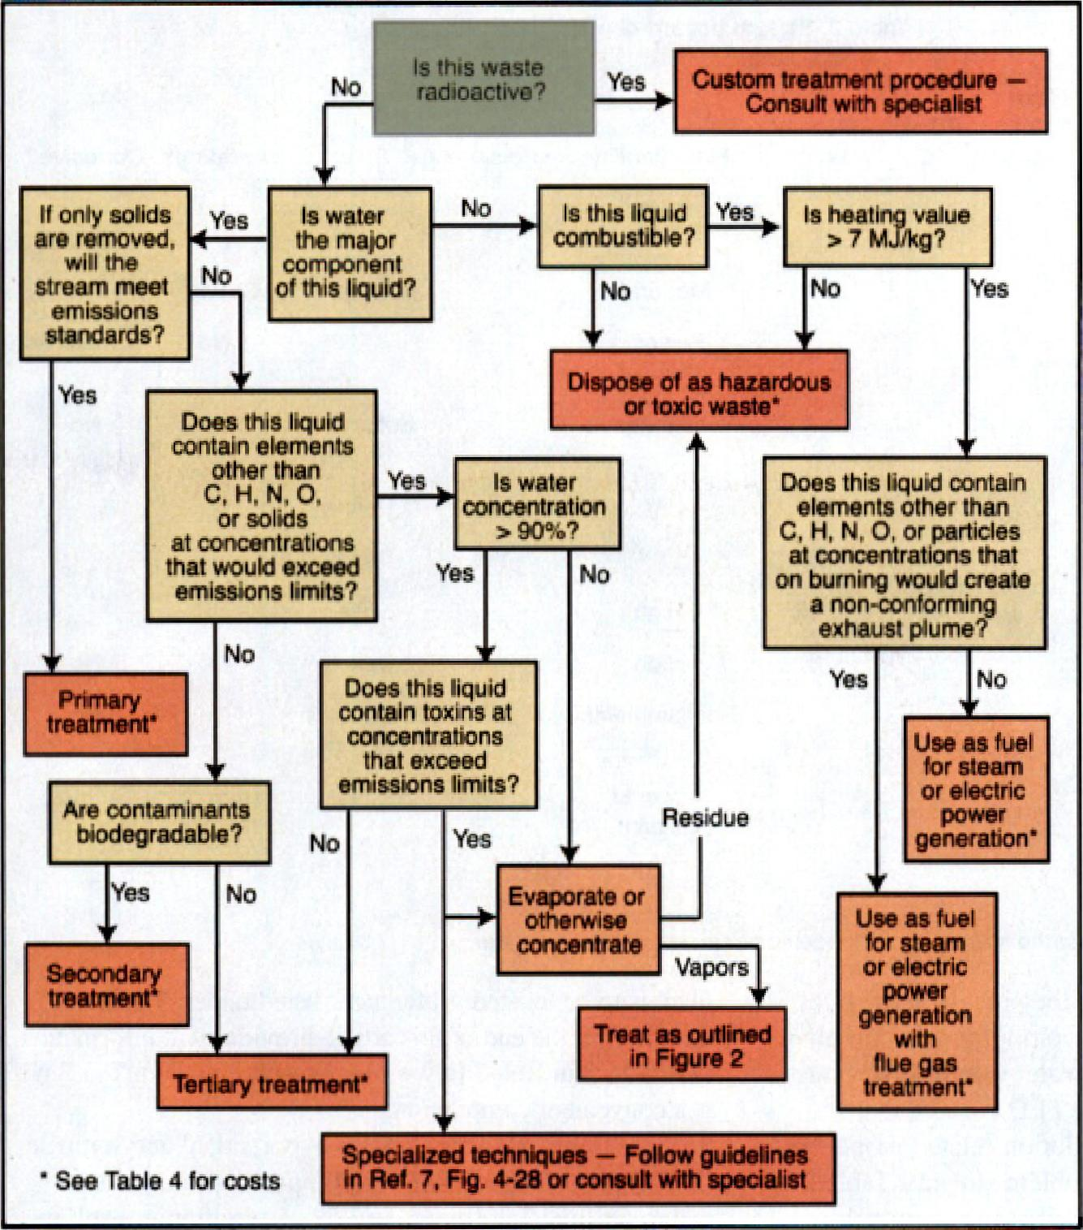

Yes

Does this liquid
  
contain elements
  
other than

C, H. N, O.

or solids

at concentrations
  
that would exceed
  
emissions limits?

Yes

No

Is this waste
  
radioactive?

**Custom treatment Consult with specie**

Yes

Yes

Is heating value
  
7 MJ:kg?

No

No

|  |  |  |  |
| --- | --- | --- | --- |
|  | | | |
| If only solids  are removed,  will the | 4- | Is water  the major  component | No |
|  |  |
| stream meet  emissions  standards? | No | of this liquid? |  |
|  |

Yes

Dispose of **as hazardous
  
or** toxic waste'

Does this liquid contain elements other Ilan C. H, N, 0, or particles at concentrations that on burning would create

a non-conforming

exhaust plume?

No

Are contaminants
  
biodegradable?

Yes

Secondary
  
**treatment'**

Does this liquid contain toxins at concentrations that exceed emissions limits?

o Yes

Evaporate or
  
otherwise
  
concentrate

Use as fuel for steam or electric power generation

with

flue gas
  
treatment'

Yes

Residue

Vapors

■

No

Specialized techniques — Follow guidelines
  
in Ref, 7, Fig, 4-28 or consult with specialist

**See** Table 4 for costs

to ation

Is vra
  
content

90

Primary
  
treatment'

**Treat as** outlined
  
in Figure 2

Tort ary treatment'

No

Use as fuel for steam or electric power generation'

**■ Figure 1. Decision** tree for **selecting among alternatives for waste treatment and disposal of liquids.**

1. **Recycle some of the wastewater to replace process water.**
2. Use **a refrigerated heat exchanger to** separate **streams by condensation and eliminate the scrubber.**
3. **Replace the scrubber with a** distillation column **hav­ing a refrigerated condenser.**

**All of these alternatives could eliminate wastewater or reduce its quantity. Process economics for each option can be evaluated by conventional techniques (7, *8).* Costs thus obtained can be compared with costs for waste treatment. A method for obtaining the latter is illustrated below,**

wwwsicheorgrosp Juno 2007 **COP**

**3. Minimize**

**As mentioned previously, the hypothetical wastewater will meet standards for dis­charge to a natural waterway if the sulfate level is reduced to less than 250 ppm and the mixed organics to non-toxic BOD levels below 30 ppm.**

**The decision tree in Figure 1 can he used to help define treatment protocols for liquids. (Figures 2 and 3, for gases and solids, appear at the end of the article.) For the ACN** waste­water **stream, the answers to the questions in Figure I are: radioactive? no; major water? yes; solids removal only? no; elements other than C, H, N and 0? yes: major water? yes; toxins? no. This leads to terti­ary waste treatment,**

**Since detailed design of waste treatment facilities is impractical in** a **study estimate, a short-cut method to estimate costs is needed. The following simple** and quick **technique, originally derived to calculate utility costs, can be used to calculate the cost of tertiary treatment for the wastewater stream described above.**

**Utility and waste treatment costs depend on two coefficients, a capital cost multiplier, a, and an energy multiplier, *b (7, 9). These* coefficients are listed in Table 4.**

**The unit cost of treating I m, of wastewater is given by:**

***Cr,„ = a(CEPC1)+ bCf (1)***

**where *CEPCI is* a capital cost index *(Chemical Engineering* Plant Cost Index) that adjusts for inflation and cis the pre­vailing price of fuel in VW. (Historical values of *CEPC1* and *Cf* can be found at** [**ulrichvasudesign.com/CEPC1.pdf**](http://ulrichvasudesign.com/CEPC1.pdf) **and** [**ulrichvasudesign.com/FP.pdf.)**](http://ulrichvasudesign.com/FP.pdf.))

**Based on a waste stream flowrate of 0.026 m3/s, coeffi­cient a, from** Table 4 for **tertiary wastewater treatment, is:**

***a* 0.001 + (2 an I0-4)q-0 5 = 0,00211**

Reproduced with permission of the copyright owner. Further reproduction prohibited without permission.

**and *h* is 0.1. Using a cost index of 500 and an energy price of 57U] (approximate current values), the unit treatment expense is estimated *to* he:**

**Table 4. Coefficients for calculating waste treatment coats,**

|  |  |
| --- | --- |
| Wastewater Treatment, Sir& '  **Primary Secondary**  **Tertiary**  **Membrane Processes, Wm, t Concentration of dissolved solids in reed 20,000-40,017O ppm**  **5,000-20,000 ppm**  **Up to 5.000 ppm**  **LiguldiSoNd Waste Disposal. &kg 3** | ***0.01 < 41, 10 rOis***  ***0.13001* 2v10-7g-1 0.002**  **0.0007 + 2 x 11 0.003**  **0.0003agc10m31s 0.001 + 2.10'c-0.6**  **0.001 c (lc i m31s**  **0.0015 + 5.10-5r" 0.13**  **0.0015 + Sir10-5q-a 5 0.08**  **0,0015 + 4300-5rr" 0.02** |

|  |  |  |
| --- | --- | --- |
| **Conventional solid or liquid waSteS Twee Or hazardous solids and liquids** By **combottloni**  **As supoiernentai %poi**  **with SA get Cleaning**  **Gas Emissions Treatment, 5/F4m3.** | **4.000-4 —**  **2.5.104 —**  **1 < x HMV < 1,000 Nilis**  **3.0x10-6{Hhill0."01-0.33 (111114**  **5_00 {101140.71m-023 -4.10-51.11110** | |
|  |  | **0.05 s q *<* 50 NmVs** |
| **Endothermic Oaring** |  | **1.10-04-025 0.004** |
| **Thermal or catelyIrc incineration** |  | **1,410-5q-"3 0.002** |
| **With hue gas Cleaning** | **1** | **5.10,504-33 0.003** |
| **By combustion** |  | **1 < *q e tw <* 1,000 64Jfe** |
| ***As* supplemental fuel** | **3.0,410-5 (Irlr'P-"Q-0.2, -0rl Cr, (ihv)** | |
| **with flue gas cleaning** | **5.0.10-5 fiVIVP "q-a.23 ON)** | |

***• Q* in total water capacity, mils. Primary treatment consists al filtration, secondary treat­ment is nitration plus activated sludge processing_ and tertiary treatment is filtration, acti­vated Sludge prOCeSSIng and ChernICal prOCOSSIng.**

**t q is total water capacity, rn,/s. In many eases, the concentrated effluent from a mem­brane separation unit Must be treated by secondary or tertiszy methods as wet, in these situations. membrane separation is not an ultimate waste treatment method. Its viability depends on the value of the purified stream and on savings avallabte insist reducing the volume of concentrated waste requiring subsequent treatment.**

**o Use these numbers advisedly. Waste disposal costs depend on local public attitude and other political lectors that are capricious and location serreithre. See Ref 5, page 25-101 kr typical U.S. regional masons.**

**ri** is the **waste's Hownate. Kg/S, and *WV* is** its **higher heating value, Ntakg_ Note that negative In these cases, because waste burning as a SUpplernentary Net returns a Credit *cliz* the total treatment system flowrate in normal (213 K, 1 atm) Cubic meters per Sec­ond, Nm3is and thv is the lower (or net} healing value in PAYNm3. Note that t7 is negative in these instances, because week burning as a supplementary Net learnt a Credit**

**= 0.0028(500) 1- 0.1($710J) = $2.1/ma**

**Assuming an operating factor of 0.92, the annual treated volume is 750,0(X) m-Vyr, The annual treatment expense is, therefore, $1,600,000. This provides a basis on which to compare some of the options identi­fied in Step 2.**

**This estimate can undoubtedly be improved given more familiarity with the process. The wastewater rate of 0.026 mYs is small compered to that of standard tertiary treatment systems. which have capacities up to I 0 m'/s. If this stream were blended with another one going to a larger treatment plant, its capital share (coefficient a) would be less and unit treatment cost smaller. This suggests searching for another similar effluent to which this waste could be added. For example, if the VvatilieWater above were part of a larger stream flowing at I mYs, the unit treatment cost would be $1.30/m3 and the annual treatment expense for the original fraction becomes $980,000, a reduction of more than one-third. For more on economics of waste­water treatment, see Ref. 10.**

**4. Isolate**

**To discharge only compounds that exist in nature, such as oxygen, nitrogen, water, carbon dioxide and minerals, is an ideal that is seldom achieved. (In the past, CO2 was not a problem compound, but with increasing concern about its contribution to the greenhouse effect, projects emitting large amounts of carbon dioxide must deal with it.) When objectionable materials contained in gas or liquid streams cannot be eliminated, the next best alternative is to convert them to a marketable byproduct, *even* when doing so costs money (see box on next page), Otherwise, wastes are usu­ally converted to solids and stored in special secure terres­trial sites under the control of licensed specialists,**

**Assume that a heavy liquid organic waste stream from the hypothetical acrylonitrile process is about 25% water and 75% mixed acrylonitrile and acetylnitrile, and it is flowing at a rate of 4 *g/s.* Also assume that the answers to the questions in Figure I are: radioactive? no; major water content? not combustible? no. Thus, this stream must be disposed of as a toxic waste.**

**Based on Table 4 and ming the same *CEPC/* and ener­gy price as before, the unit treatment cost is:**

**C,„,„ = a(500} + b(S7G.1) = $1.2514**

**At 4 gis, the annual disposal cost is $150.0001yr.**

CIP. June 2007 **www.actie.o*cep**

Reproduced with permission of the copyright owner. Further reproduction prohibited without permission.